#
# 20191029
# SD#3353704
#
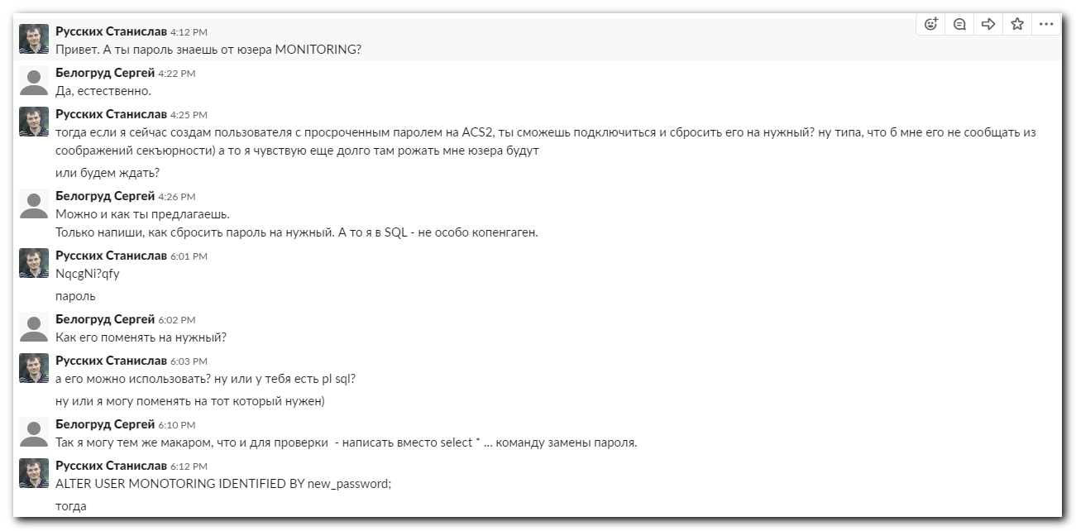

https://www.w3resource.com/sql/database-security/change-passwords.php
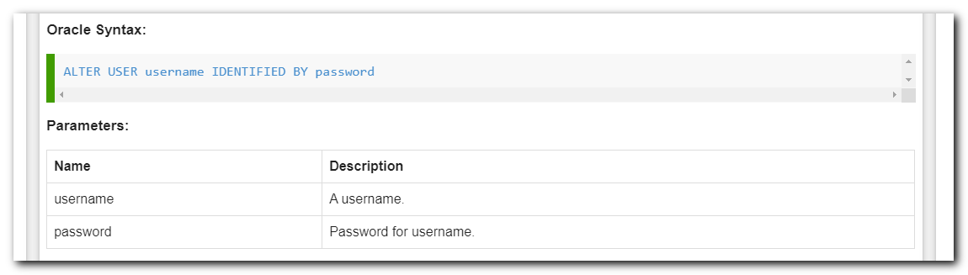

#
# I’ve changed line with SELECT to follow line and run it.
# It’s reuire space symbol between the password and “;”.
ALTER USER MONITORING IDENTIFIED BY **** ;
# And replact string with password in sh script to that one time password.

# In the first run I’ve received follow.
[root@vm-dbamon01 ~]# /opt/TCS/scripts/nagios/plugins/acs/tcs_monitor_acs_mir_requests.sh
ERROR. Result=ALTER USER MONOTORING IDENTIFIED BY ****
*
ERROR at line 1:
ORA-01031: insufficient privileges
[root@vm-dbamon01 ~]#

# Then, I add space symbol and run it again.
# After script ran, I’ve received follow.
[root@vm-dbamon01 ~]# /opt/TCS/scripts/nagios/plugins/acs/tcs_monitor_acs_mir_requests.sh
ERROR. Result=
[root@vm-dbamon01 ~]#

